Kindness (in Crisis)
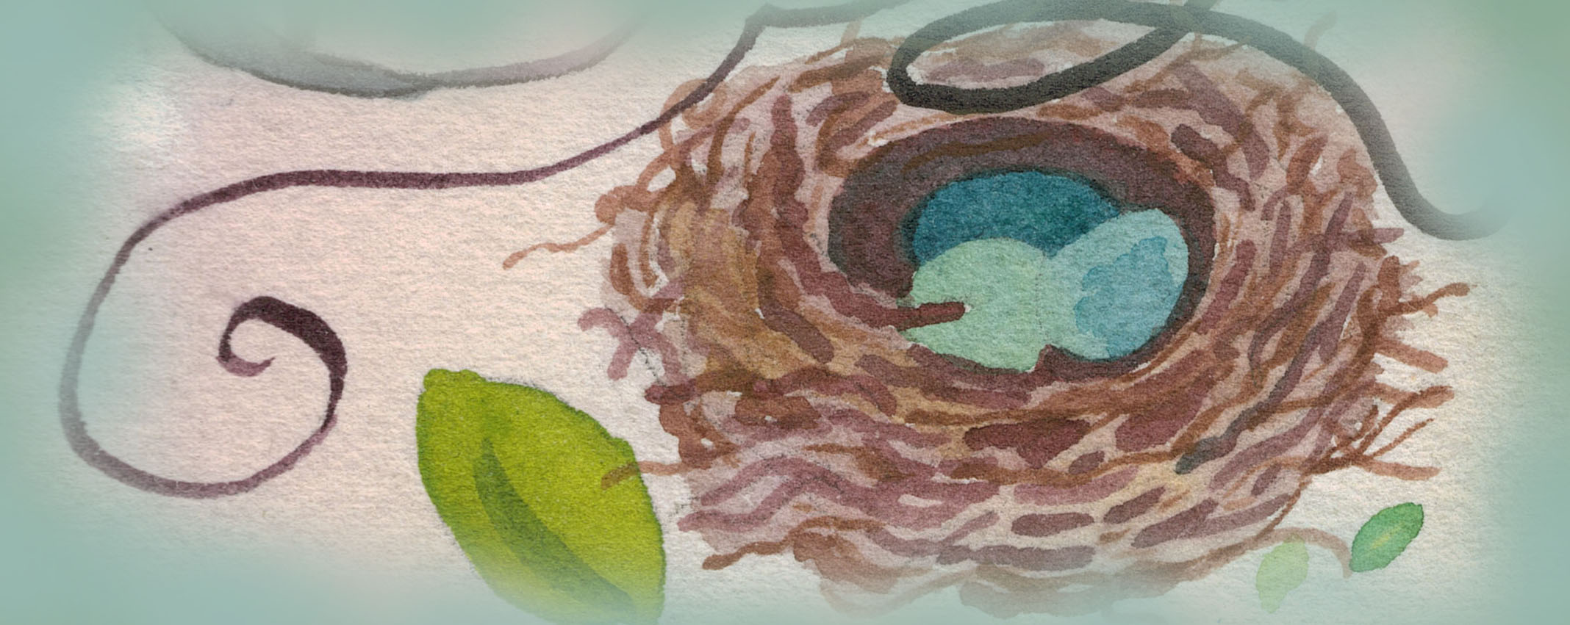

The Side Effects of Kindness -

“Brain imaging studies indicate that kind and compassionate feelings cause physical changes in the prefrontal cortex of the brain, biased to the left-hand side . . . an area associated with positive emotion.” --Dr. David R. Hamilton, author of The Five Side Effects of Kindness

Kindness

Before you know what kindness really is
you must lose things,
feel the future dissolve in a moment
like salt in a weakened broth.
What you held in your hand,
what you counted and carefully saved,
all this must go so you know
how desolate the landscape can be
between the regions of kindness.
How you ride and ride
thinking the bus will never stop,
the passengers eating maize and chicken
will stare out the window forever.

Before you learn the tender gravity of kindness
you must travel where the Indian in a white poncho
lies dead by the side of the road.
You must see how this could be you,
how he too was someone
who journeyed through the night with plans
and the simple breath that kept him alive.

Before you know kindness as the deepest thing inside,
you must know sorrow as the other deepest thing.
You must wake up with sorrow.
You must speak to it till your voice
catches the thread of all sorrows
and you see the size of the cloth.
Then it is only kindness that makes sense anymore,
only kindness that ties your shoes
and sends you out into the day to gaze at bread,
only kindness that raises its head
from the crowd of the world to say
It is I you have been looking for,
and then goes with you everywhere
like a shadow or a friend.

From Words Under the Words: Selected Poems. Copyright © 1995 by Naomi Shihab Nye. Reprinted with the permission of the author.

Gone Missing
“Before you know what kindness really is, you must lose things.” –Naomi Shihab Nye

Retrace my steps
Check. Check again.
What if somebody . . .

Panic. Recollect my small affairs
Stubs and coupons hidden compartments
Cards giving me credit I don’t deserve

Lost things needing protection
Wrong hands toying
Fingers sliding
Gifts and secrets
Now ditch-tossed
Wallet empty, leather folds hanging out like tongues

A place where my name once belonged

