Breaking Through Blocks
by Christi Krug
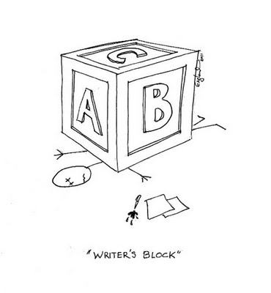
The blank screen glares at you with its open document. Go ahead, dummy, write a good story. You’re a lousy plotter by the way. (Tapping foot.) Better flesh out these boring characters. (Fingers frozen at the keys.) And sheesh, your dialogue sucks!
We writers are pretty amazing. We battle opposing forces every time we sit down to write. One mode is creative, one critical. They aren’t necessarily “left brain” and “right brain” because the physiology is complex and research is ongoing. Yet you and I can each feel the shift when working in one mode or the other. The biggest struggle is how to keep our forward momentum when we are continually halted by criticism.
Let’s call the two styles of thinking Dr. Codger and the Dream Kid, the seats of contrasting characteristics.

Dr. Codger Dream Kid
Logic | Emotion
Structure | Free-flow
Analysis | Hunches
Order | Chance
Language | Storytelling
Labels | Essence
Editing | Creating
Plans | Spontaneity
Schedules | Timelessness
Revisions | Ideas
Work | Play
Dr. Codger is the mode in which we live our everyday lives—going to work, paying bills, fulfilling obligations. Always focused on results, Dr. Codger watches the clock, responsibly getting us where we need to go. Dream Kid, on the other hand, springs from fire. She is burning with curiosity and passionate about life. Passionate, creative writing can only begin when this wild child strikes the first match.
At the same time, our challenge is that Dr. Codger, as well as the left-brain faculties, governs language. Therefore, every time we set to jot down a journal entry or pen a poem, we can’t avoid his way of thinking, full of criticism and judgment. We have to learn how to deal with this mindset. Only then can we create when it’s time to create, edit when it’s time to edit, and avoid letting Dr. Codger destroy our ideas, possibilities and output before they get a chance.

